Problem 5

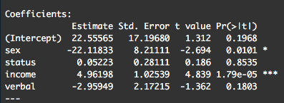

Sex and income are statistically significant at the 5% level.

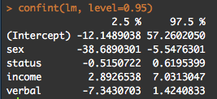

1. Sex is just a dummy variable representing the categorical data of sex. 1 represents female and 0 represents male.

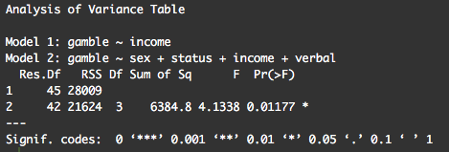

Since the p-value is very small the null hypothesis is rejected.

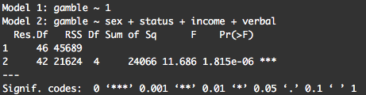

Appendix

# title: "MSDS596 - HW2"

# author: "Diego Sarachaga"

# date: "10/02/2018"

library(faraway)

data(teengamb)

lm <- lm(gamble ~ sex + status + income + verbal, teengamb)

summary(lm)

#a

# Coefficients:

# Estimate Std. Error t value Pr(>|t|)

# (Intercept) 22.55565 17.19680 1.312 0.1968

# sex -22.11833 8.21111 -2.694 0.0101 *

# status 0.05223 0.28111 0.186 0.8535

# income 4.96198 1.02539 4.839 1.79e-05 ***

# verbal -2.95949 2.17215 -1.362 0.1803

# ---

# Signif. codes: 0 ‘***’ 0.001 ‘**’ 0.01 ‘*’ 0.05 ‘.’ 0.1 ‘ ’ 1

#

# Residual standard error: 22.69 on 42 degrees of freedom

# Multiple R-squared: 0.5267, Adjusted R-squared: 0.4816

# F-statistic: 11.69 on 4 and 42 DF, p-value: 1.815e-06

#Sex and income are statistically significant at the 5% level

confint(lm, level=0.95)

#Confident intervals

#sex -38.6890301 -5.5476301

#income 2.8926538 7.0313047

#b

#Sex is a dummy variable representing the categorical data of sex. A 1 represents female and a 0 represents male.

#c

lmi <- lm(gamble ~ income, teengamb)

summary(lmi)

anova(lmi, lm)

# Analysis of Variance Table

#

# Model 1: gamble ~ income

# Model 2: gamble ~ sex + status + income + verbal

# Res.Df RSS Df Sum of Sq F Pr(>F)

# 1 45 28009

# 2 42 21624 3 6384.8 4.1338 0.01177 *

# ---

# Signif. codes: 0 ‘***’ 0.001 ‘**’ 0.01 ‘*’ 0.05 ‘.’ 0.1 ‘ ’ 1

#Since the p-value is so small the null hypothesis is rejected.

#d

nullmod <- lm(gamble ~ 1, teengamb)

anova(nullmod, lm)

# Analysis of Variance Table

#

# Model 1: gamble ~ 1

# Model 2: gamble ~ sex + status + income + verbal

# Res.Df RSS Df Sum of Sq F Pr(>F)

# 1 46 45689

# 2 42 21624 4 24066 11.686 1.815e-06 ***

# ---

# Signif. codes: 0 ‘***’ 0.001 ‘**’ 0.01 ‘*’ 0.05 ‘.’ 0.1 ‘ ’ 1